Fintry Primary School

School Improvement Report
Session 2024-2025

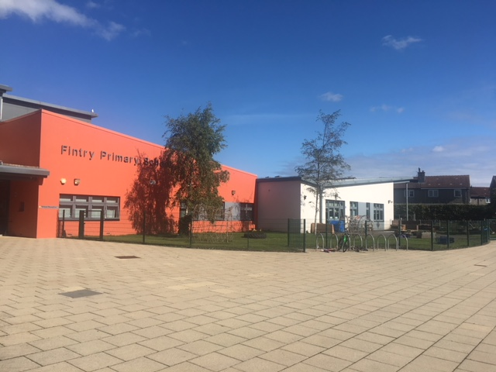
(Photo / Logo)

Fintry Primary School
Findcastle Terrace,
Dundee. DD4 9EL
Tel 307840
Email: fintry.primary@dundeecity.gov.uk

This document shares and celebrates the improvements in our School and embraces all ages and stages. It is based upon our School Improvement Plan for session 2024-2025

School Aims:
At Fintry we have a shared vision and core values for our school.

“If you can dream it, you can do it”
Walt Disney

- Friendship
- Inclusion
- Nurture
- Trust
- Respect
- You

Aims:
- To empower our learners to meet new challenges with confidence, enthusiasm, resilience and success.
- To provide a welcoming, safe, nurturing, supportive and stimulating learning environment which will enable each child to achieve his/her full potential.
- Encourage and support each child to develop in a climate of co-operation, trust and respect.
- Establish, develop and maintain effective partnerships with parents, support agencies, and the wider community, and together, help each child realise his/her full potential irrespective of gender, race, belief or disability
- Achieve this through the continuing lifelong learning of a committed, caring staff, high quality leadership and management, and the recognition and promotion of achievement and excellence of all.

Context of the School:
Fintry Primary School was opened in 1954 and the Nursery in 1960. Both schools came together in 2009 in a modern new build situated in the grounds of the old school in the North East of the City of Dundee. Fintry Primary School and Early Years Centre currently welcomes 363 pupils in 14 classes. Our nursery class offers provision for children from 2 to 5 years old. We have an Enhanced Support Area providing more specialist teaching for pupils with additional and complex needs.

The Scottish Index of Multiple Deprivation (SIMD) identifies small concentrations of multiple deprivation across all of Scotland in a consistent way. 33% of our pupils live in deciles 1 & 2 and over 90% live in deciles 1-4, indicating that they live in a region that has been identified as having areas of poverty and inequality.

The School received £145,775 Pupil Equity Funding. This was used to pay for additional teaching staff which has allowed us to develop our Nurture Provision by adding the Flamingo Room to the Nest. It was also used for additional support staff, Our Active Schools Assistant and our SFDW. who are deployed across the school to assist in raising attainment and meeting individual’s needs.

Every Dundee Learner Matters (EDLM) is the Strategy for Dundee City to raise attainment and close the attainment gap. In school this session staff have continued to develop their research programmes. We have had staff working with CYPIC to focus on the development of writing at first level and also our whole school focus on attendance. Work carried out across curricular areas will continue to inform our School Improvement Plan moving forward as we identify good practice and learn through our enquiry what works best for the children and families in Fintry Primary School and Early Years Centre. At the Centre of EDLM are the 3 Ps:
Presence – ensuring all children attend regularly and promptly,
Participation- creating a climate within school where all pupils feel welcome and valued,
Progress – developing policies and practices that maximise achievement and ambitions of all pupils.
The selection of our enquiry research had these three guiding principles at the centre.

Attainment Data 2024-2025
(percentages)
 | Reading | Writing | Talking and Listening | Numeracy
Primary 1  (CFE Early Level) | 73% | 78% | 92% | 80%
Primary 4  (CFE 1st Level) | 80% | 80% | 86% | 80%
Primary 7  (CFE 2nd Level) | 81% | 67% | 84% | 76%

Action Points:
- Writing will continue to be a focus for our learning next session. We will take part in the implementation wave of the CYPIC writing project which is aimed at P4.
- 4 of our children in the P1 cohort are working towards individual milestones, this counts for 8% of the total.
- 1 of our children in the P7 cohort is working towards induvial milestones, this counts for 2% of the total.

Review of Improvement Progress for Session 2045-2025

- School Improvement Priority 1: Presence – Attendance for All – What do we offer to pull our learners to school?

Progress and Impact:

SDFW and DHT attended 2 days course in Glasgow as part of the CYPIC Attendance group. Data was scrutinised and a target group of 6 pupils identified for cycle 1 of resilience group. DHT and SFDW met with families to share attendance levels and the purpose of the group. The group met weekly with SFDW. Attendance levels for 5 of the children improved over the group time, however sustained improvement was shown for 2 of these pupils.

Pupils completed the Glasgow Motivational and Wellbeing Toolkit. Teachers were given time to analyse the data for their class and then discuss main actions with the learners. From the 256 responses average rating for the following questions –
I like this school – 7.8/10
I work hard in this school – 8.4/10
I am good at working with others – 7.82/10
I like being chosen to do things in school – 8.13/10
Other pupils look out for me in school/make sure I am feeling ok – 7.67/10
I have friends in the school – 9.26/10
I am proud of the work I do in school/my work is good – 8.42/10
I can wait until it is my turn – 8.15/10
I can stand up for myself in school – 8.38/10
Adults look out for me in school/make sure I am feeling ok – 8.69/10
People in school can help me if I get upset – 8.15/10
Teachers tell me what I am good at – 8.65/10
I follow the school rules – 8.73/10
People listen to me in school – 7.66/10
I feel safe in school – 7.77/10
I belong to school/I feel important to the school – 8.14/10
I will keep trying even if the work is hard – 8.66/10
I stay calm even if I don’t get what I want – 7.91/10
I would complain if I felt picked on by anyone in school – 8.14/10
I feel good about myself in school – 8.73/10

STEM Breakfast Club set up for a target group of children. This supported 6 pupils coming to school in the morning.

Active Schools Assistant has been used to support pupils with a soft start each morning. Targeted groups have been successful with pupils more able to come to school and then be ready to learn.

Next Steps

Continue to implement our attendance processes to ensure we are working in partnership with our families to maintain high levels of attendance for all. Daily phone calls regarding attendance and monthly monitoring of all pupils 90% and below.

Weekly meetings with SFDW to discuss high level messages from Attendance monitoring and group work. Tight focus on attendance and early intervention.

Questionnaire to parents in term 1 – gather evidence about barriers to attendance.

SFDW to have a focus on attendance and run groups for parents and pupils around resilience and getting to school. Data used to target priority groups. This will include Decider Skills for parents/carers.

Use of KIT bag to support children to get to the root of non-attendance.

Share monthly attendance figures with pupils and wider school community – track if this has an impact.

Continue to engage Active Schools Assistant to provide target supports to engage learners in coming to school.

- School Improvement Priority 2: Participation – Getting it Right at Fintry PS – How good is our universal provision?

Progress and Impact:
All staff reviewed their class environment by engaging with the Inclusive Classroom Audit. SLT met with groups of learners from each class to discuss what it is like to be a learner in each primary. Feedback was given to each teacher. Pupils showed pride in the class and liked their environment.

We also worked with the Pedagogy Team to review class displays and have made a Fintry Standard. Teachers have a template to support them to make a plan for their new class in Aug. Pupil voice showing us that they think displays could be better across the school.

All staff completed de-escalation training in Nov 24. This allowed us to make a set of scripts to support biggest issues across the school. Feedback from staff shared that they feel more confident in supporting young people.

Pt SfL lead a session for staff on ABLe planning. This has provided a more consistent approach across the school. ABLe plans have been shared with parents so there is a greater transparency about strategies used and the evaluation of progress throughout the year.

SLT shared input at Inset about the effective use of support staff. This promoted good professional dialogue, and we shared examples of good practice. Support staff to be planned for effectively by each class teacher.

Continued focus on Fintry Values. We see almost all the pupils being able to talk about these confidently. They are displayed in all classrooms, and we have trophies shared at Assembly each week. All Assemblies are linked back to the Values, and a social target is set and discussed. There is a greater sense of community within the school and this needs to be built upon.

We set up a nurture space this session – The Flamingo Room. This has been hugely successful and is supporting a number of pupils. The room is flexible, with children dipping in and out as required. However, it mainly supports 7 key pupils from across the school. The room is also open over break times and pupils have been able to access a smaller space and be supported by staff as required. Feedback from pupils, staff and parents shows us that the Flamingo Room has been a welcomed addition to the school.

Visual in place to support restorative practice, staff are more confident about using this approach, however we need to ensure this is consistent across the school.

Next Steps:
All teaching staff to use their Display Action Plan to create an effective learning environment. Agreed standard in place and should be reflected in all rooms. Ensuring environments are welcoming.

We are Fintry whole school display. Each child to have own space where they will then reflect on themselves as a learner, this will be updated termly. Use the language from child version of progression pathways – including meta skills and next steps.

Continue to use the Glasgow Motivation and Wellbeing Profile for all learners to get a better understanding of how the pupils view themselves as learners at Fintry PS.

Training for all staff – Decider Skills. This will support a focus on regulation across the whole school. Use as part of universal support across the whole school. Share with parents at TATC meetings and target parent sessions (see priority 1).

Ensure ABLe Plans, Care Plans, Single Child Plans and our TATC processes welcome and support the families, ensuring the Child’s voice is at the centre.

Review our data to ensure we are targeting the correct pupils at the correct time with the correct intervention – robust planning, tracking and monitoring meetings/discussions. Introduce Data Profiles and new SEEMIS tracking tool. Continued partnership working to ensure interventions are in place eg Ancrum, Aberlour, Active School Assistant etc

Teaching staff to use new planning format for all curricular areas. They will also plan the use of support staff using new format. SLT to ensure deployment of staff meets the needs of the learners at Fintry PS. Use Active Schools Assistant to target social and emotional groups as well as Sporting Activities.

Fluid model of support to be implemented across the Nest. Data and assessment information to be reviewed to inform decisions around support for pupils.

As a school, revise and implement Action Plan to support gaining Silver Award for Rights Respecting School. Pupil Leadership Group to be developed.

School Improvement Priority 3: Progress – Progress for All – with a focus on writing

Progress and Impact:
All class teachers tracking learner progress against the DCC progression pathways. Tracking meetings have taken place 3 times over the year which has allowed us to share predicted levels of achievement over the session. Big questions asked about our data by SLT, ensuring staff are confident about discussing a learner’s journey. We are beginning to see a more robust set of data around achievement of a level. T
The SEEMIS tracker was not available this session so this task and learning will be a focus for next year.

All classes focused on the teaching of the description bubble at the start of the session. Classes have these on display and learners can talk about this as was evident from our pupil forum conversations. Description bubbles are supporting the learners with their writing tasks.

PT and staff from P4 classes attended the CYPIC Writing Project this session. This has involved a new methodology of improvement in writing. The aim was to improve writing attainment at 1st level with 70% of learners achieving this milestone. At June 25 we have ……………………

HT led sessions about the daily write at the start of the session. Cold assessment tasks were assessed to see what the focus of learning was to be in each class, based on the tools for writing. Each class teacher completed a pareto chart to track and monitor this intervention. Pupil forum discussions show that most learners are enjoying daily write activities.

All class teachers introduced a word wall in their class. This was to aid vocabulary building and to support pupils with their writing. Staff can see the benefit of this display and this is something which is now part of the Fintry Standard.

Next Steps:
Continue daily write opportunities across the school. All staff to use pareto charts to track and monitor the success of this targeted intervention.

Senior Leaders and P4 staff to be involved in the next wave of CYPIC Writing Project. Staff to take part in CLPL sessions and then implement. Colleagues involved last year to continue with methodology.

All class teachers to engage with child version of progression pathway for writing and use this to create learning ladders in class to aid pupil knowledge of expectations and next steps.

Fresh Start reading intervention for targeted P6-P7 pupils. Input 4 times minimum over the week.

Target support for P3 cohort – start by focusing on children who are off track – 32/50 on track for numeracy, 21/50 on track for reading, 27/50 on track for writing and 32/50 on track for listening and talking. Priority groups to be identified for 6 weeks blocks interventions.

Target support for P1-P4 cohort on reading. Class teachers in these classes to keep 1:1 tuition folder so fluid support given as required. Reading Leaders to deliver CLPL on 1:1 tuition for teaching and support staff.

Reading Leaders to make good use of Portal resources to ensure all staff are upskilled in using data from assessments to ensure high quality learning and teaching experiences are on offer. Use additional teacher to allow Reading Leaders time out of class.

Cost of the School Day
We continue to strive to reduce costs for all our families at Fintry PS. This session we have done this by the following:
- Whole school offered a trip to Science Centre which was free of charge, the Science Centre also contributed to the cost of transport for this. We were therefor able to offer this trip to all our learners free of charge.
- Our Parent Council have supported us when purchasing the P7 hoodies by donating £350 and school also made a contribution, so this reduced the cost for parents to £10. The Parent Council survived the parents to see if this was acceptable for parents.
- Parent Council and school also supported the cost of the P7 residential for 12 pupils so they could all attend.
- We have clothing rails at the front entrance for families to help themselves.
- SFDW applied for Christmas gifts to support families.
- SFDW is supports families with finance as and when required.
- Pencils, rubbers and rulers and on offer in each classroom for all children, this reduces any stigma of not having equipment in class.
- Summer event in school as a fun day which is to no cost for the children and families.
- P7 Leavers Show was free to all parents/carers so there were no barriers to attending.

Improvement Priorities for Session 2025 - 2026

- Attendance for All – Building a resilient community

- We are Fintry – developing resilient pupils and respecting their voice

- Progress for All – with a focus on writing, STEM and targeted interventions.

Please visit www.careinspectorate.com or https://education.gov.scot/what-we-do/inspection-and-review/reports for Care Inspectorate or HMIE Inspection Reports.

https://parentzone.org.uk/

Further Information can be found at:

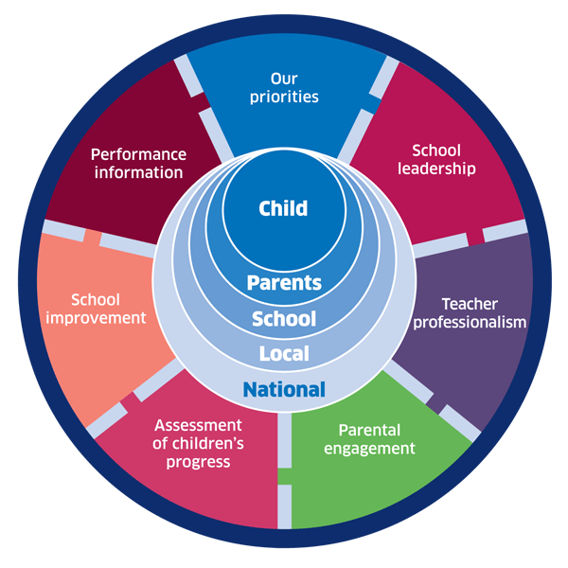 | 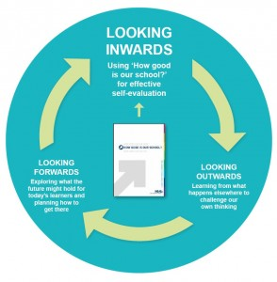 |  |   Dundee Education Plan  https://www.dundeecity.gov.uk/sites/default/files/publications/annual_education_plan_2017-18.pdf
National Improvement Framework  http://www.gov.scot/Publications/2016/01/8314 | HGIOS 4 Self-evaluation https://education.gov.scot/improvement/Documents/Frameworks_SelfEvaluation/FRWK2_NIHeditHGIOS/FRWK2_HGIOS4.pdf | Tayside Plan C&FS  External Link ' Tayside_Plan 1a.pdf'

