School Context as at Dec 2025

School Roll | School Attendance | Percentage ASN | PEF Allocation
332 | 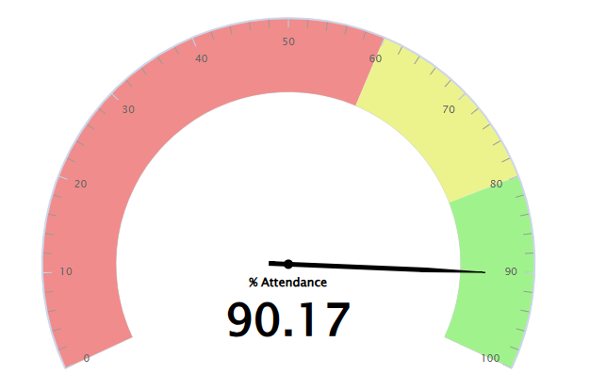 | 29.50% | £145,775
SIMD Profile
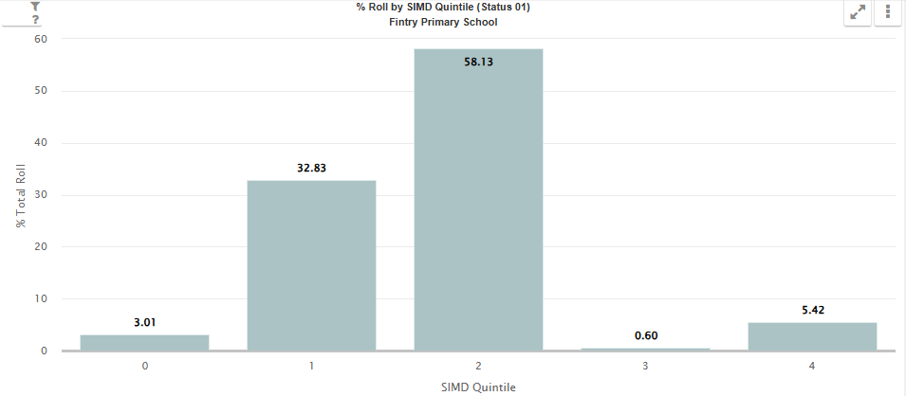

Cycle of Improvement

Vision Values and Aims

Our Vision:
The vision of Fintry Primary School is to build a culture of inclusion by empowering our learners to meet new challenges with confidence, enthusiasm, resilience, and success.

Our Values:
Friendship, Inclusion, Nurture, Trust, Respect You

Our Aims:

- To provide a welcoming, safe, nurturing, supportive and stimulating learning environment, which will enable each child to achieve their full potential.
- Encourage and support each child to develop in a climate of co-operation, trust and respect.
- Establish, develop, and maintain effective partnerships with parents, support agencies and the wider community, and together, help each child realise their full potential irrespective of gender, race, belief or disability.
- Achieve this through the continuing lifelong learning of committed, caring staff, high quality leadership and management, and the recognition and promotion of achievement and excellence of all.

If you can dream it, you can do it” – Walt Disney


School Priorities 2025-2026

SCHOOL VERSION SIP Priority 1
Specific area for improvement |  |  | Attendance for All – Building a resilient community
Rationale for Improvement  (based on evidence from key stakeholders) |  |  | Attendance levels are lower than DCC average, we improved slighty but have not reached our stretch aim yet.
Equity Gap (if relevant) |  |  | Early Intervention and Prevention
NIF PRIORITIES  Closing the attainment gap between the most and least disadvantaged children and young people  Placing the human rights and needs of every child and young person at the centre of education | NIF DRIVERS  Parental Engagement  School Improvement  Choose an item. |  |  | EDLM PRIORITY    Presence |  | PEF (where applicable)  Intervention for equity & cost  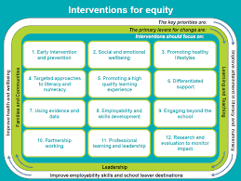  10. Partnership working  1. Early Intervention and Prevention  3. Promoting Healthy Lifestyles  SFDW  ASA |  | HGIOS QI  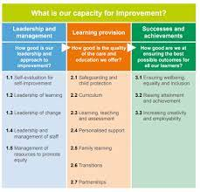  1.5 Management of resources to promote equity  3.1 Enquring wellbeing, equality and inclusion
Intended Outcome (impact) |  | Actions required to reach desired outcome |  |  | Measurement & Evidence |  | Who |  | When | Resources
Increase attendance levels for all – from 90.6% to 92% |  | Continue to implement our process to ensure we are working in partnership with our families to maintain high levels of attendance for all. Daily phone calls regarding attendance and monthly monitoring of all pupils 90% and below.  Weekly meetings with SFDW to discuss high level messages from Attendance monitoring and group work. Tight focus on attendance and early intervention. Teachers to flag concerns/pattern via cause for concern forms.  Questionnaire to parents in term 1 – gather evidence about barriers to attendance.  School inquiry focus SFDW to have a focus on attendance and run groups for parents and pupils around resilience and getting to school. Data used to target priority groups. This will include Decider Skills for parents/carers.  Use of KIT bag to support children to get to the root of non-attendance.  Share monthly attendance figures with pupils and wider school community – track if this has an impact.  Engage Active Schools Assistant to provide target supports to engage learners in coming to school. |  |  | Attendance data to be reviewed each month, database to be used to track trends.  Attendance database  Parent/Carer questionnaires  Use Glasgow Motivational each term and Wellbeing Toolkit for each child, how do they view themselves as a learner?  Observations/discussions  PDSA model for targeted interventions with parents and pupils.  Run chart of attendance figures  Monthly run chart.  PDSA models  How well do we ensure that all children feel safe, healthy, achieving, nurtured, active, respected, responsible and included?  How effectively do we allocate resources to sustain improvement priorities? |  | SLT and SFDW  DHT and SFDW  Teachers  DHT  SFDW and DHT  All staff  DHT  ASA |  | Monthly  Weekly  By end of Sept  Start Sept for cycle 1  Complete by end of term 1  Start from Aug 25 and share monthly  Review every 6 weeks | Data from City, spreadsheet  SFDW  Time, spreadsheet, cause for concerns  Questionnaires  Glasgow toolkit  Space for groups – use Finmill Centre, KIT bags  ASA
Progress
This box should be used to note progress throughout the session

SCHOOL VERSION SIP Priority 2
Specific area for improvement |  |  | We are Fintry – developing resilient pupils and respecting their voice
Rationale for Improvement  (based on evidence from key stakeholders) |  |  | High number of pupils with ASN across the school, we need to ensure we are getting it right for all. A high number of pupils are unable to engage in their class so we need to review personalised supports and provide tools for staff so they can support all learners.
Equity Gap (if relevant)

NIF PRIORITIES  Placing the human rights and needs of every child and young person at the centre of education  Improvement in children and young people's health and wellbeing | NIF DRIVERS  Assessment of Children's Progress  Teacher Professionalism  Performance Information |  |  | EDLM PRIORITY  Participation |  | PEF (where applicable)  Intervention for equity & cost  5. Promoting a high quality learning experience  6. Differentiated support  7. Using evidence and data  Resources  ASA  Partnerships |  | HGIOS QI  3.1 Enquring wellbeing, equality and inclusion  2.4 Personalised support
Intended Outcome (impact) |  | Actions required to reach desired outcome |  |  | Measurement & Evidence |  | Who |  | When | Resources
Getting it right for all learners – to ensure each child is held at the centre. We have created an environment to support all learners needs. We aim to have a reduction of dysregulated behaviours and for all staff to feel equipped to support each learner. |  | SIP focus work around QI 2.4 Inclusion – We are Fintry is a focus for challenge within visits to our school. A focus on learner profiles universal, targeted and removing barriers for all learners.  All teaching staff to use their Display Action Plan to create an effective learning environment. Agreed standard in place and should be reflected in all rooms. Ensuring environments are welcoming.  We are Fintry whole school display. Each child to have own space where they will then reflect on themselves as a learner, this will be updated termly. Use the language from child version of progression pathways – including meta skills and next steps.  Continue to use the Glasgow Motivation and Wellbeing Profile for all learners to get a better understanding of how the pupils view themselves as learners at Fintry PS.  Training for all staff – Decider Skills. This will support a focus on regulation across the whole school. Use as part of universal support across the whole school. Share with parents at TATC meetings and target parent sessions (see priority 1).  Ensure ABLe Plans, Care Plans, Single Child Plans and our TATC processes welcome and support the families, ensuring the Child’s voice is at the centre.  Review our data to ensure we are targeting the correct pupils at the correct time with the correct intervention – robust planning, tracking and monitoring meetings/discussions. Introduce Data Profiles and new SEEMIS tracking tool. Continued partnership working to ensure interventions are in place eg Ancrum, Aberlour, ASA etc  Teaching staff to use new planning format for all curricular areas. They will also plan the use of support staff using new format. SLT to ensure deployment of staff meets the needs of the learners at Fintry PS. Use ASA to target social and emotional groups as well as Sporting Activities.  Fluid model of support to be implemented across the Nest. Data and assessment information to be reviewed to inform decisions around support for pupils.  As a school, revise and implement Action Plan to support gaining Silver Award for Rights Respecting School. Pupil Leadership Group to be developed. |  |  | SLT Learning Walks – use the agreed Fintry Standard for displays to provide effective feedback for staff.  Pupil forums – using Wee HGIOS  Pupil forums – can the children articulate the language of learning to know themselves as a learner?  Analyse data from the pupils, each teacher to use this as self-evaluation and planning for next steps in their class.  Staff questionnaires – pre and post CLPL session.  Reduced number of incidents – monitor exclusions and VI data monthly.  HT to lead SLT staff in CLPL on TATC processes – feedback from families, pupils and observations of meeting.  Effective use of tracking tools – using SEEMIS Tracker when available. HT to devise PEF tracker to view interventions. Class Data Profiles should reflect discussions at tracking.  Discussions at tracking and planning – interventions to be planned for.  Review use of new curriculum planners in May 26.  PDSA models for impact as part of ASA work.  Reflected through TATC meetings, pupil engagement. Through ongoing professional dialogue and engagement with all stakeholders.  Review progress against targets in action plan. Gaining the award – evidence visit.  How well do we ensure that all children feel SHANARRI?  How well do children and young people show consideration for others and demonstrate positive behaviour?  How do we ensure there is an ethos and culture of inclusion, participation and positive relationships across the whole learning community? |  | Class teachers and SLT  Class teachers, pupils and SLT  Class teachers  All staff  SLT  SLT  All teaching staff.  SLT  SLT and all staff  ASA and SLT  PT SfL to keep overview  PT to lead, class teachers, leadership group |  | Start Term 1  Ongoing over the session, start Term 1  Term 1  Start Nov Inset  Ongoing, discuss termly  Tracking meetings Nov, Feb and May and SLT weekly meetings  Termly meetings  Regular ASA meetings  Regular meetings  By end of session 25/26 | Check lists  Corridor displays, learning walks questions.  Glasgow Toolkit  Staff time, Decider Skills materials, VI data  Templates of plans for Fintry.  Class Dad Profiles, PEF Tracker, SEEMIS tool, PEF monies.  Proformas for planning.  Data sets  UNCRC resources
Progress
This box should be used to note progress throughout the session

SCHOOL VERSION SIP Priority 3
Specific area for improvement |  |  | Progress for All – with a focus on writing, STEM and targeted interventions.
Rationale for Improvement  (based on evidence from key stakeholders) |  |  | Attainment data over time has been poor in writing 72% (20/21), 62% (21/22), 45% (22/23) and 64% (23/24) for achieving 1st level at the end of P4. STEM has been focus for RCT and teacher feedback shared the need for support and professional learning in this area. P3 cohort data shows continued poor attainment for this cohort.
Equity Gap (if relevant) |  |  | Targeted approaches to Literacy and Numeracy
NIF PRIORITIES  Improvement in attainment, particularly in literacy and numeracy  Closing the attainment gap between the most and least disadvantaged children and young people | NIF DRIVERS  Assessment of Children's Progress  School Improvement  Teacher Professionalism |  |  | EDLM PRIORITY  Progress |  | PEF (where applicable)  Intervention for equity & cost  4. Targeted approaches to literacy and numeracy  7. Using evidence and data  5. Promoting a high quality learning experience |  | HGIOS QI  2.3 Learning, Teaching and Assessment  3.2 Raising attainment and achievement
Intended Outcome (impact) |  | Actions required to reach desired outcome |  |  | Measurement & Evidence |  | Who |  | When | Resources
To improve writing attainment at 1st level – this targets the P4 and P5 classes.  By June 26 80% of P4 learners will have achieved CfE 1st level writing (baseline 76%).  By June 26 20% of P5 learners will have achieved CfE 1st level writing (13 children off track, 10 to achieve).  For all teaching staff to feel confident teaching STEM back in their classes, building a sustainable model.  Deploy additional 1TE of class teacher to target literacy and numeracy groups across the school. Focus on pupils in P3 are off track. P6-P7 who are off track for reading. and to support 1:1 tuition across P1-P4 classes. |  | Continue daily write opportunities across the school. All staff to use pareto charts to track and monitor the success of this targeted intervention.  Senior Leaders and P4 staff to be involved in the next wave of CYPIC Writing Project. Staff to take part in CLPL sessions and then implement. Colleagues involved last year to continue with methodology.  All class teachers to engage with child version of progression pathway for writing and use this to create learning ladders in class to aid pupil knowledge of expectations and next steps.  Jayne Ross and Bethany Westwood to deliver CLPL opportunities for STEM as per action plan for all teaching staff.  STEM to be delivered back in class. STEM leaders to support effective deployment of resources to support this.  Fresh Start reading intervention for targeted P6-P7 pupils. Input 4 times minimum over the week.  Target support for P3 cohort – start by focusing on children who are off track – 32/50 on track for numeracy, 21/50 on track for reading, 27/50 on track for writing and 32/50 on track for listening and talking.  Priority groups to be identified for 6 weeks blocks interventions.  Target support for P1-P4 cohort on reading. Class teachers in these classes to keep 1:1 tuition folder so fluid support given as required.  Reading Leaders to make good use of Portal resources to ensure all staff are upskilled in using data from assessments to ensure high quality learning and teaching experiences are on offer. Use additional teacher to allow Reading Leaders time out of class. |  |  | Pareto charts, measuring impact of intervention.  Analysis of data  Moderation activities  Evidence within written pieces, can pupils transfer knowledge?  Pupil forums – can they articulate where they are in their learning for writing and what their next steps are?  Teacher questionnaires  Pupil voice  Trackers, assessments.  ACEL data review  Regular planning and evaluation meetings with PEF intervention teacher. Interventions to be tracked to monitor progress and impact -PDSA models  Assessment data of each child to show learning journey.  Termly reviews to ensure groups are targeting the correct children.  Professional dialogue with teachers and through pupil discussions – are resources being planned for and used effectively?  How well do we record, analyse and use assessment information to identify development needs for individual learners and specific groups?  How well do we use evidence from tracking meetings, professional dialogue and assessments to measure progress over time and in particular points of transition? |  | class teachers  SLT and identified class teachers  Class teachers  STEM leaders, class teachers  SLT, PEF teacher, class teachers, Reading Leaders. |  | Termly  Starts Nov 25  CLPL for staff in by Oct and then in action  CLPL in term 1  Start term 1 and review every 6 weeks | Cold pieces of writing, pareto charts, tools for writing framework  Time from WTA  WTA time, STEM timetables, STEM resources  Literacy resources, Learning to Read Data, Oxford Owl, Portal, WTA time, effective timetables.
Progress
This box should be used to note progress throughout the session

SCHOOL VERSION
Further PEF Interventions  (not included in SIP) |  |  | Targeted Interventions to support raising attainment in Literacy and Numeracy  Targeted interventions to support wellbeing.
Equity Gap (if relevant) |  |  | Targeted approaches to literacy and numeracy. Social and Emotional Wellbeing
NIF PRIORITIES  Improvement in attainment, particularly in literacy and numeracy  Improvement in attainment, particularly in literacy and numeracy  Improvement in children and young people's health and wellbeing | NIF DRIVERS  Assessment of Children's Progress  School Improvement  Performance Information |  |  | EDLM PRIORITY  Progress |  | PEF (where applicable)  Intervention for equity & cost  4. Targeted approaches to literacy and numeracy  2. Social and Emotional Wellbeing  3. Promoting Healthy Lifestyles |  | HGIOS QI  3.2 Raising attainment and achievement  3.1 Enquring wellbeing, equality and inclusion
Intended Outcome (impact) |  | Actions required to reach desired outcome |  |  | Measurement & Evidence |  | Who |  | When | Resources
A consistent approach to teaching reading is evident across the infant classes for learning to read.  Staff confident at tracking progress of each learner and using the data available to plan effective next steps in learning.  The use of technologies to support teaching of literacy and numeracy to be clearly evident in each class across the school. |  | Continued use of Ruth Miskin Portal to support Learning to Read.  Continued used of Oxford Nelson and Oxford RWI Spelling to support Literacy across the school.  Continued use of Sum Dog and Numicom subscriptions to support learning in Numeracy. Resource also to be used as part of the assessment process to help inform teacher judgements of achievement of a level. |  |  | Regular planning and evaluation meetings with PEF intervention teacher. Interventions to be tracked to monitor progress and impact.  Assessment data of each child to show learning journey.  Termly reviews to ensure groups are targeting the correct children.  Professional dialogue with teachers and through pupil discussions – are resources being planned for and used effectively?  Review of ACEL data.  How well are we removing barriers to learning to ensure equity for all?  How well is our focus on literacy and numeracy leading to raising attainment across the curriculum?  How well can we demonstrate improved attainment for groups and individuals facing barriers to learning, including poverty? |  | Reading Leaders, class teachers, support staff, SLT |  | Start Sept 24 and monitor every 6 weeks | ACEL data, PEF Tracker, Fresh Start materials, resources to support learning across literacy and numeracy.  ICT equipment, data
Progress
This box should be used to note progress throughout the session

